**FTP Service CentOS-9**

Steps to implement ftp service in centOS-9

1. Install Ftp service using command **yum install vsftpd\***

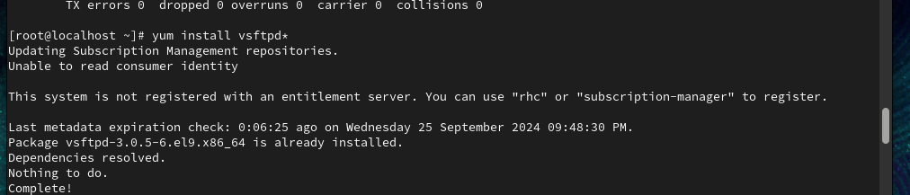

1. Enabling and starting ftp service

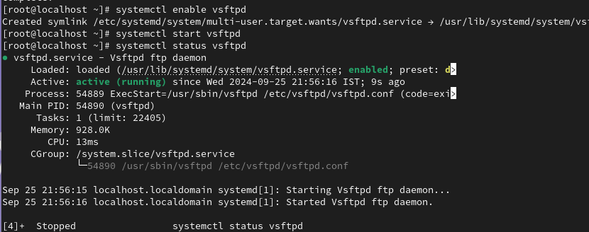

1. Checking for firewall



1. Creating a user for ftp

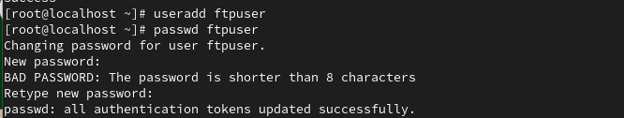

1. Ping ftp

